Calculator Hex

A game for 2 players

Easy Version

Players take it in turns to:

3 4 5 6 7 8 9

1. Pick a hexagon on the board
2. Pick two numbers from the pool that multiply together to give the number in the hexagon (You can pick the same number twice)
3. Cover the hexagon with a counter if the result is correct

The winner is the first player to make a path of counters connecting their sides of the board.

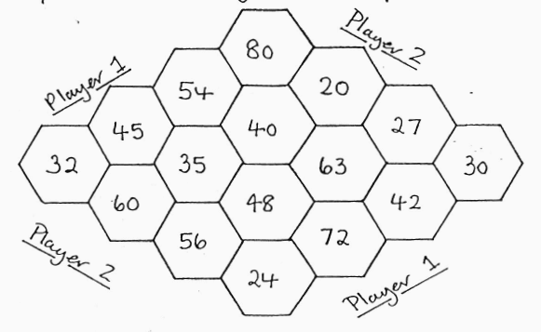

Calculator Hex

A game for 2 players

Harder Version

19 99 29 39

1. 59

69 79 89 99

